Guide 2. APT Project Development
Progress Report | NexusWST / WeStorage | October 2026 snapshot | Jean Carlos Díaz Pérez and Cristopher Alberto Lobos Martínez
October 2026 progress snapshot: Sprint 0 is complete and Sprint 1 is approaching closure. The reported outcomes concern design, technical preparation, and planning; they are not evidence of a fully deployed product.

1. APT project progress summary
Progress summary | Sprint 0 is complete and the project foundations have been consolidated: BPMN As-Is/To-Be v1.0, ERS/DAS and project charter v1.0, use cases, 4+1 architectural views (components, deployment, packages, states, and sequence), roles matrix, and a Docker-based skeleton (Docker, Traefik, Redis, and PostgreSQL). The team produced 18 version 1.0 user stories with 129 tasks, as well as two PERT analyses. The latest Jira screenshot shows 10 of 12 Sprint 1 activities completed, mockups v0.5 in progress, and validation of the pending-decisions register v0.9 with Ismael still outstanding. Functional development is planned for Sprint 2 and is not reported as implemented.
Objectives | The general and specific objectives defined in Phase 1 remain in place: modernize We Manager, prioritizing the end-to-end Orders process supported by Clients, Products, and authentication/roles. Task sequencing was adjusted to complete architecture, requirements, and infrastructure before functional implementation; the core scope remains unchanged.
Methodology | The team uses Scrum in two-week sprints, with a product backlog, planning, reviews, retrospectives, and Jira tracking. Jean Carlos serves as Scrum Master and Cristopher as Product Owner, according to Sprint Planning 2. Definition of Ready (DoR) and Definition of Done (DoD) criteria were documented; the actual execution of testing, code reviews, and pipelines belongs to future increments.
Progress evidence | Available evidence: Jira Sprint 1; ERS/DAS and project charter v1.0; finalized BPMN diagrams; use cases, 4+1 and sequence diagrams; roles matrix; Docker skeleton; version 1.0 user stories and tasks; analysis/design PERT and development/testing/closure PERT; Sprint Review and Retrospective. Jira and PERT visuals are attached; API execution, tests, and SonarQube metrics will require future evidence.

2. Work plan monitoring
Status is compared against the Phase 1 work plan and the updated Jira screenshot. C1–C5 refer to the five graduate profile competencies selected in Guide 1.

Activity tracking | NexusWST
Code | Activity | Resources | Timing | Owner | Observations | Status | Adjustments
C3, C4 | Requirements and decisions | ERS v1.0; Jira; register v0.9 | Weeks 1–3 | Jean / Cristopher | ERS/DAS and charter drafted at v1.0; selected items await validation. | Adjusted | Validate register v0.9 with Ismael.
C3, C5 | BPMN and use cases | As-Is/To-Be BPMN; use cases | Weeks 2–4 | Cristopher / Jean | BPMN v1.0 and use cases completed. | Completed | Incorporate future client feedback.
C2, C5 | Data model | ERD; PostgreSQL | Weeks 2–5 | Cristopher / Jean | Preliminary model available; final schema outstanding. | In progress | Compare against WeStorage’s definitive model.
C1, C5 | 4+1 architecture | DAS; diagrams; PERT | Weeks 3–5 | Jean | Views and component, deployment, package, state, and sequence diagrams completed. | Completed | Maintain versions during implementation.
C1, C5 | Docker foundation | Docker; Traefik; Redis; PostgreSQL | Sprint 1 | Cristopher | Container skeleton completed in Jira; external environments depend on client. | Completed | Connect GitLab, testing, deployment when access exists.
C3, C4 | Stories and planning | Stories v1.0; 129 tasks; PERT; Jira | Sprint 1 | Jean / Cristopher | 18 stories v1.0, estimates, two PERT diagrams, and Sprint Planning 2. | Completed | Manage capacity and Sprint 2 DoR/DoD.
C1, C3 | Scope mockups | Figma; WeStorage branding | Sprint 1 | Jean | Mockups v0.5 are still in progress. | In progress | Finish screens and request validation.
C3, C4 | Client validation | Pending decisions v0.9 | Sprint 1 | Jean / Cristopher | Jira still shows SCRUM-49 as To Do. | Not started | Distinguish critical open issues from approved decisions.
C1, C2 | Clients, products, security | Go; Next.js/React; DB | Sprint 2 | Jean / Cristopher | Stories allocated to Sprint 2; no implemented increment shown. | Not started | Build to acceptance criteria.
C1, C2 | Orders and integration | Go; API; INVAS; Redis | Sprint 2+ | Cristopher / Jean | Order intake, validation, search, and history prioritized. | Not started | Use simulator for INVAS if necessary and document.
C1, C5 | Testing and quality | GitLab; SonarQube; tests | Sprint 2+ | Jean / Cristopher | DoD documented, but no executed testing reported. | Not started | Test incrementally and report QA results.
C4, C5 | Project closure | Jira; evidence; reports | Phase 3 | Jean / Cristopher | Current report tracks progress, not a final working release. | Not started | Compile testing, review, and final delivery.

3. Adjustments from monitoring
Enablers and challenges | Progress benefited from the division of work between Jean and Cristopher, Scrum/Jira, Ismael’s general acceptance of the architecture, and an initial data model. Constraints included pending business-rule confirmations, the definitive database schema, and the client’s availability. The team prepared use cases and diagrams internally and consolidated open questions in the v0.9 decisions register for later validation.
Adjusted activities | Scope was preserved while planning was refined: BPMN diagrams, technical views, user stories, and the Docker skeleton are marked completed in Jira; mockups v0.5 are still in progress and validation of the v0.9 decisions register remains pending. Redis and queues for INVAS were introduced in the design; user profiles will be configurable, and NexusWST will not include a Picker role. Sprint 2 prioritizes authentication, client companies, products, and the beginning of the Orders workflow.
Pending activities and risks | The development stories are not late: they are scheduled for Sprint 2 (October 21–November 3). Key risks are the sprint workload (70 planned points), dependencies on INVAS and the client-provided GitLab/environments, and open business-rule confirmations. Sprint Planning 2 provides an option to move H-06 back to the backlog if capacity is insufficient and to use a simulator for H-07 if INVAS is unavailable. Tests, production integration, and SonarQube results have not yet been completed.

Available evidence and traceability
- Sprint 1 Jira board showing ten completed activities.
- User Stories v1.0 (18 stories) and User Story Tasks v1.0 (129 tasks).
- Sprint Planning 2: dates, owners, DoR/DoD, risks, and delivery sequence.
- Provided PERT diagrams: analysis and design; development, testing and closure.
- Sprint Review and Sprint Retrospective, together with the pending-decisions register v0.9.

Appendix A. Sprint 1 status (Jira)
Screenshot provided by the team. Mockups in progress and decision validation pending.
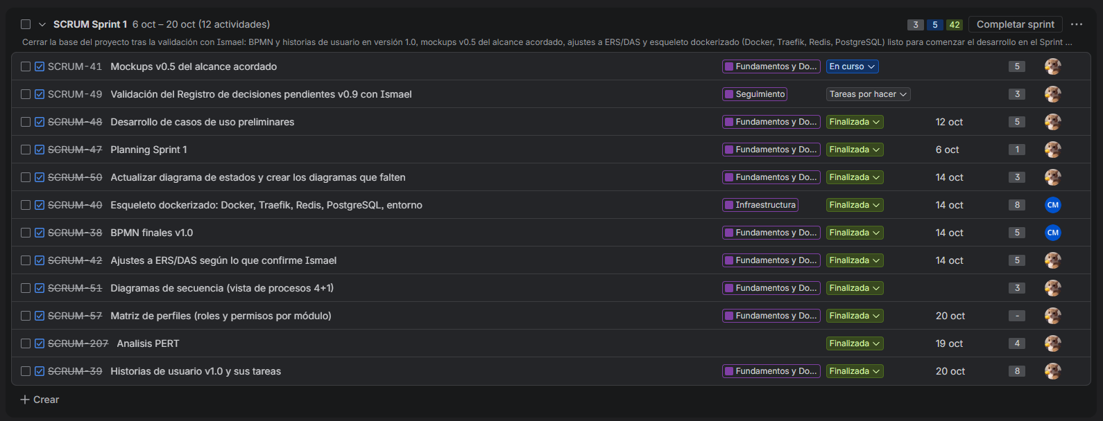

Appendix B. Analysis and design PERT
PERT diagram provided by the NexusWST team.
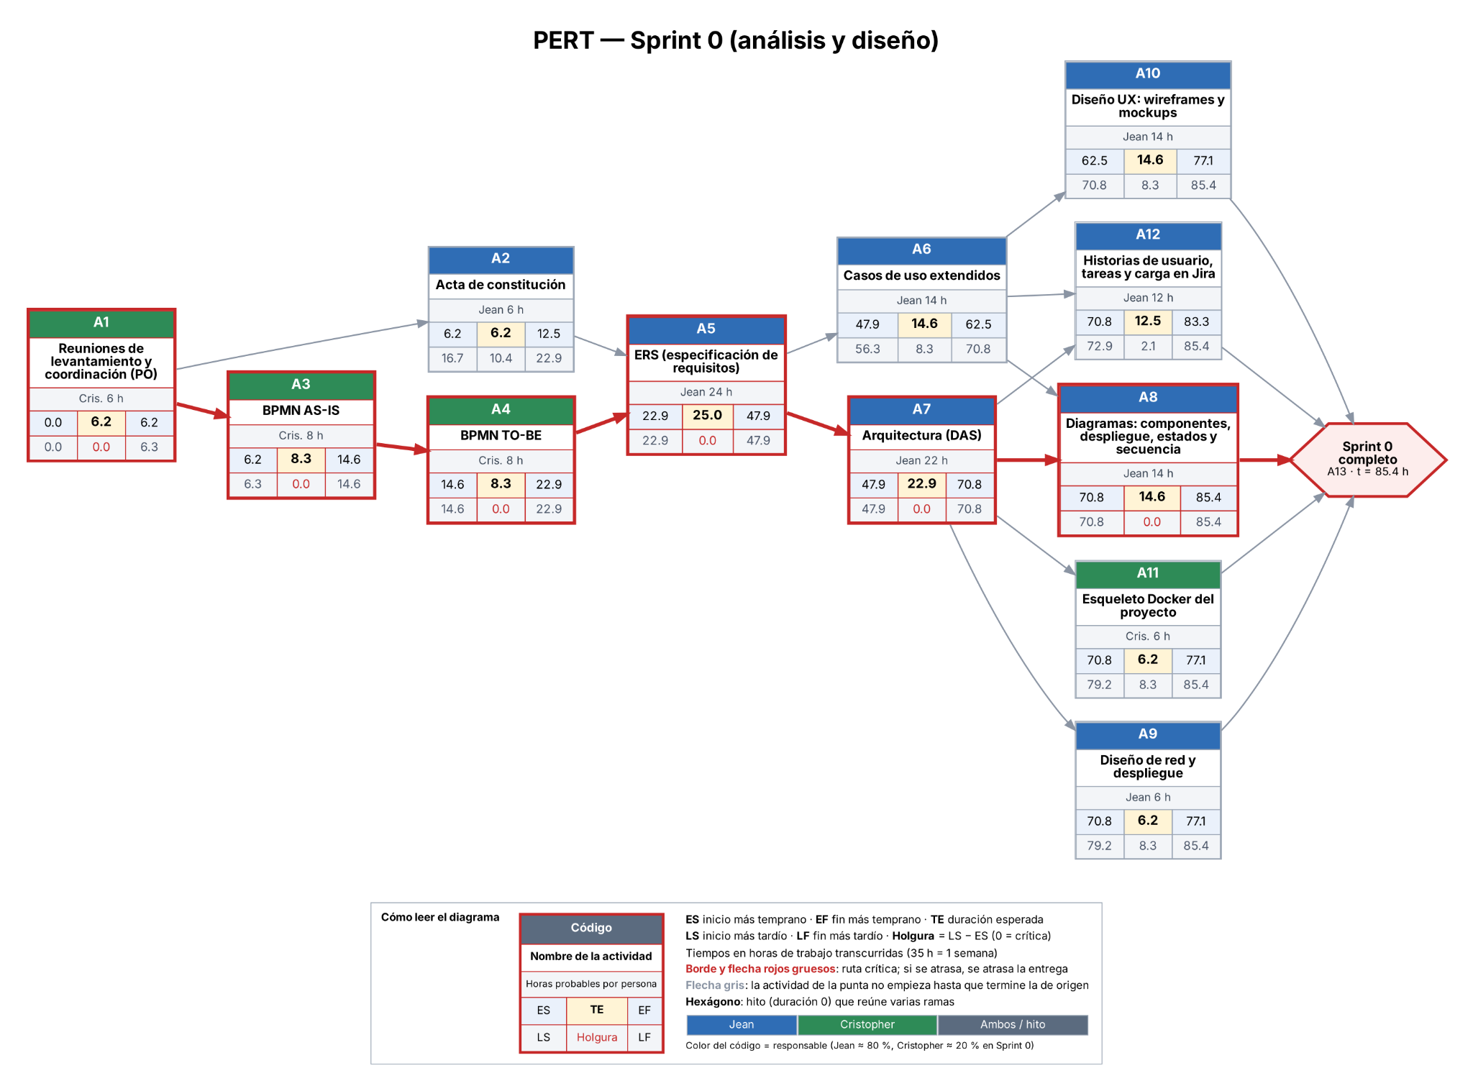

Appendix C. Development and testing PERT
Dependency plan; it does not represent features already implemented.
